University of New Haven

Introduction to Data Science

DSCI-6002-01

#### Unlocking the Art of Writing

#### ( Analyzing Behavioral Patterns for Enhanced Writing Quality Assessment )

**By**

**ASHISH AGARWAL**

**SOWMYA BATHULA**

**HARSHITHA G.S**

**SHAAGUN SURESH**

### CONTENT

1. Abstract
2. Introduction
3. Executive Summary
4. Methodology

4.1. Business Understanding

4.2. Data Understanding

4.3. Data Preparation

4.4. Modeling

4.5. Evaluation

4.6. Deployment

1. Conclusion
2. Future Work
3. References

### ABSTRACT

This study investigates the dynamic relationship between the process of writing and the resultant quality of written content. Through an analysis of various writing methodologies, strategies, and stages, it aims to establish correlations between the processes employed by writers and the excellence of their output. By examining factors such as pre-writing techniques, drafting, revision, editing, and the utilization of feedback, this research seeks to identify the pivotal aspects of the writing process that significantly influence the overall quality of written works. The findings of this study are expected to contribute valuable insights into optimizing writing practices to enhance the quality and effectiveness of written communication across diverse contexts and audiences.

### INTRODUCTION

The art of writing is a multifaceted process, encompassing various stages that writers navigate to produce high-quality content. Understanding the intricate connection between the writing process and the resulting writing quality is crucial for writers, educators, and researchers alike. This study delves into the correlation between the methodologies, strategies, and stages involved in the writing process and the ultimate caliber of the written work. By exploring these interconnections, it aims to shed light on how different writing processes impact the quality and efficacy of written compositions.

## EXECUTIVE SUMMARY

## The objective of this endeavor is to deploy a comprehensive framework that bridges the findings from the correlation between writing processes and writing quality into practical applications. This deployment aims to transition the identified correlations and methodologies, initially discovered through research, into accessible tools and educational resources. By leveraging technology and pedagogical strategies, the objective is to empower educators, writers, and learners with user-friendly platforms or guides derived from these insights. The deployment seeks to foster improved writing methodologies and enhanced writing quality among users, ultimately bridging the gap between research findings and practical implementation within educational and professional settings.

### Methodology

### 4.1 BUSINESS UNDERSTANDING

Intelligent tutoring and grading systems aim to assist educational institutions in refining teaching methods and boosting students' writing skills and academic progress. These systems introduce innovative approaches, equipping educators with advanced tools tailored to individual student needs. By utilizing these systems, schools create more personalized learning experiences, pinpointing areas where students require additional support and offering specific guidance. This approach fosters enhanced writing abilities and overall academic achievements among students.

Skill assessment using effective tools offers great potential to empower individuals to maximize their capabilities. These assessment tools offer in-depth insights into a person's strengths and areas needing improvement across a wide range of skills. With this information, people can personalize their growth journey, honing specific skills essential for personal and professional development. This empowerment through skill assessment allows individuals to proactively enhance their skills, leading to success in various life domains

### 4.1 DATA UNDERSTANDING

The table below represents the attributes of the data.

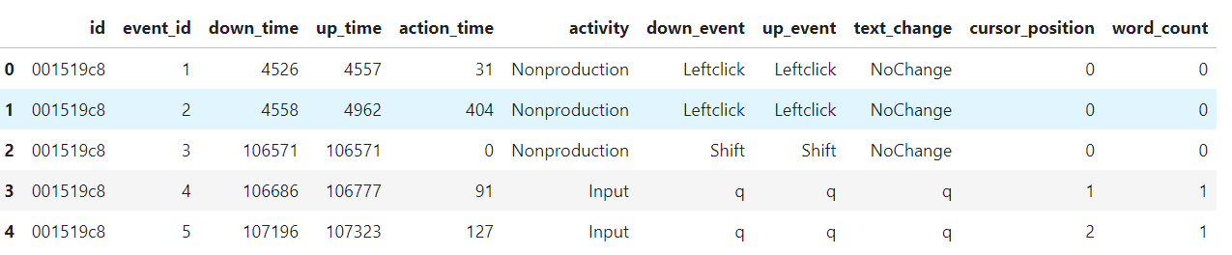

Fig 4.1

* Id: Id column represents the user/writer.
* Event id: It is a unique column, which represents the number events that occurred.
* Down time: It is the press time of the key on the keyboard.
* Up time: It is the release time of the key on the keyboard.
* Action time: It shows the difference between up time and down time.
* Activity: It stores the values entered by user was an input or non-production.
* Down event: It represents the down-time event of the key as an input [q] or non-production key on the key board [shift key, enter key, right click, left click and so on].
* Up event: It represents the up-time event of the key as an input [q] or non-production key on the key board [shift key, enter key, right click, left click and so on].
* Text change: It shows whether if there is any change of the key from the keyboard.
* Cursor position: It holds the number of the inputs given and moves further as cursor from that position.
* Word count: It depicts the number of words.

### 4.2 DATA PREPARATION

1. **DATA TRANSFORMATION:**  In the process of enhancing the predictive accuracy of our model, we implemented a critical data transformation step involving the creation and addition of new features to our dataset. Specifically, we introduced two four features named 'Total_Positive_wait_time', 'Total_Negative_wait_time' , ‘Count_Positive_wait_time’ and ‘Count_Negative_wait_time’ aimed at refining the model's ability to forecast outcomes more accurately. Adding more features strengthens our model's forecasting ability by enabling it to extract more complex patterns from the data. The code to create new features are shown in figure 4.2.1 and 4.2.2.

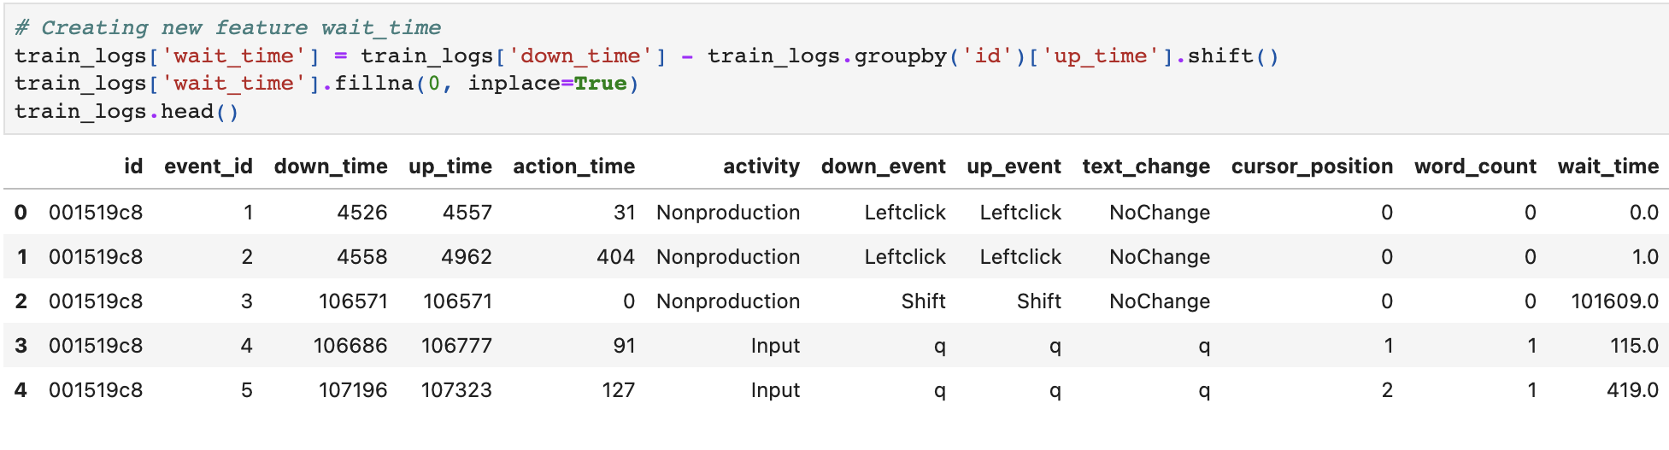

Fig 4.2.1

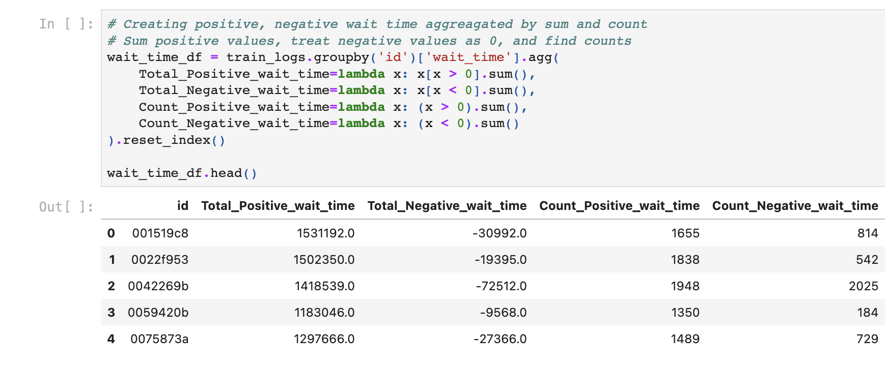

Fig 4.2.2

1. **FEATURE ENGINEERING:** We using essay constructor method to generate essays for different users as in below fig 4.2.3. Here the essay’s generated are encoded as 'qqqq'.

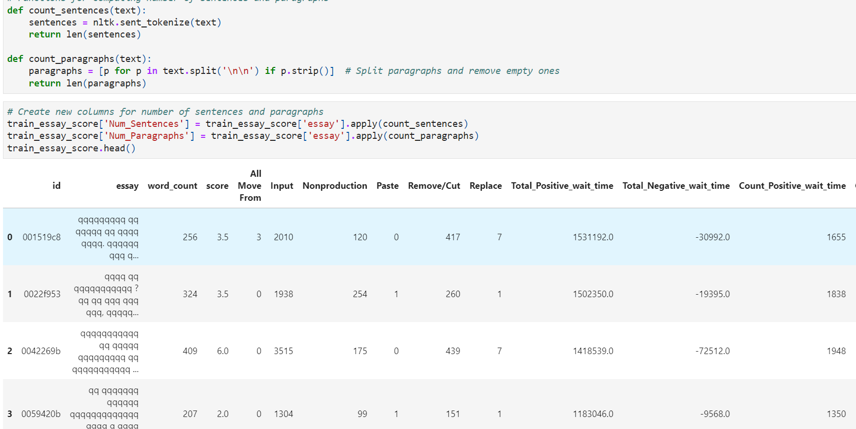

Fig 4.2.3

We have also used ‘nlkt’ library in the feature engineering process for the count of number of sentences and paragraphs present in the respective user’s essay. However, the number of the model features are enhanced such as word count, score, number of action input, number of Non production, total positive wait time, Total negative wait time, count positive wait time, count negative wait time, number of sentences and number of paragraphs for the precision model accuracy.

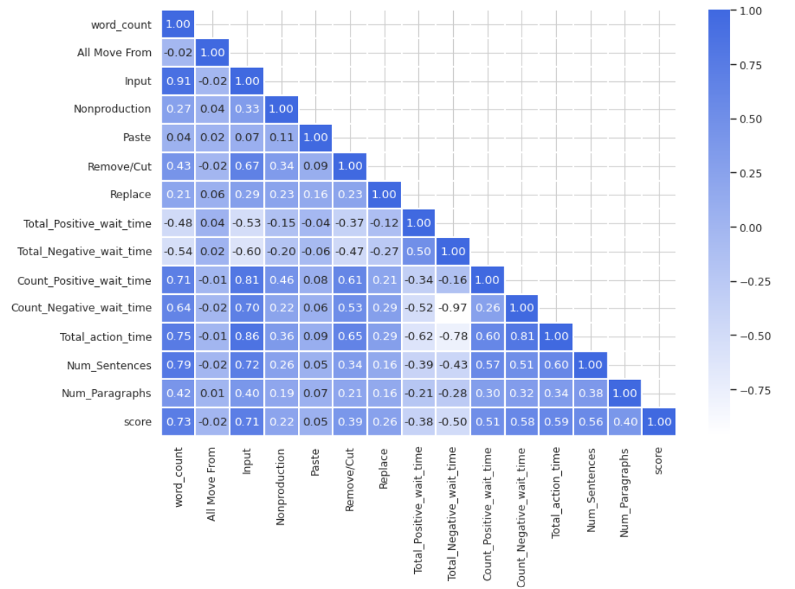

Fig 4.2.4

Fig 4.2.4 depicts that the word count is directly proportional to score and score is inversely proportional to Total negative wait time.

1. **DATA AUGMENTATION:** The below fig 4.2.5 depicts less data points of 1976 and there is class imbalance with lowest and highest data sets. Therefore, to overcome this class imbalance we are augmenting the data by extra noise factor as in fig 4.2.6.

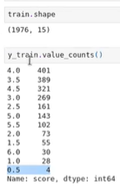 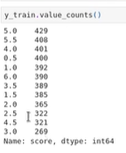

Fig 4.2.5 Fig 4.2.6

### 4.3 Modeling

fig 4.3

It builds a neural network model with a sequential structure especially for regression tasks using the Keras framework. A scaler is used to normalize the input data, and many densely related layers with ReLU activation functions are used in the construction of the model. Additionally, dropout layers are used to lessen overfitting. The mean squared error loss function is used in the model's creation, which occurs using the RMSprop optimizer. During the training process, callbacks for early stopping and model checkpointing are included to avoid overfitting and preserve the top-performing model. The best model is uploaded with the model checkpoint after training has ended, and it is then used to forecast the test data. These predictions are further adjusted by clipping them within a defined range and rounding them to the nearest half. Lastly, a sample of true values versus predicted values is printed to assess the performance of the model.

Fig 3.3.1

The text that is provided shows the first five exact numbers in addition to the estimated values that come from a regression model's evaluation. It is an example of a comparison where the estimated values represent the model's predictions and the accurate values represent the actual results, like ratings or scores. The shown values show the extent to which the model's predictions and the real data match.

### 4.4 Evaluation

Fig 4.4-Training and validation loss over epochs

This interactive graph provides useful data about the model's performance during training. It clearly shows how the loss decreases with every epoch, showing a change in the model's functionality. The model looks to be having a good understanding of the data based on the training loss's small drop and the validation loss's somewhat bigger decline. Interactive feature makes it simple to look into the model's learning processes. This graph helps the process of choosing and improving the model by providing a thorough overview of the model's training progress.

### 4.5 Deployment

In the deployment phase of this project, the transition from Jupyter Notebook to a fully functional web application using Django on the Azure cloud platform was the focal point. Leveraging the insights and models derived from Jupyter Notebook's data analysis, the integration into Django framework facilitated the transformation into an interactive web-based tool. Azure's robust infrastructure, particularly the Azure Web Server, emerged as the ideal hosting environment for this application. Through Azure's App Service, the deployment process was streamlined, ensuring efficient utilization of resources and scalability. The culmination of this deployment journey marked the successful transition from development to a live environment accessible to end-users.

The demo application has been deployed at the url :

<https://team-2-dsci-6002-f23-fp-unlocking-the-art-of-writing.azurewebsites.net/>

The code is hosted on GitHub:

https://github.com/CRLannister/Unlocking-the-Art-of-Writing/



Fig 4.5 - Application main page

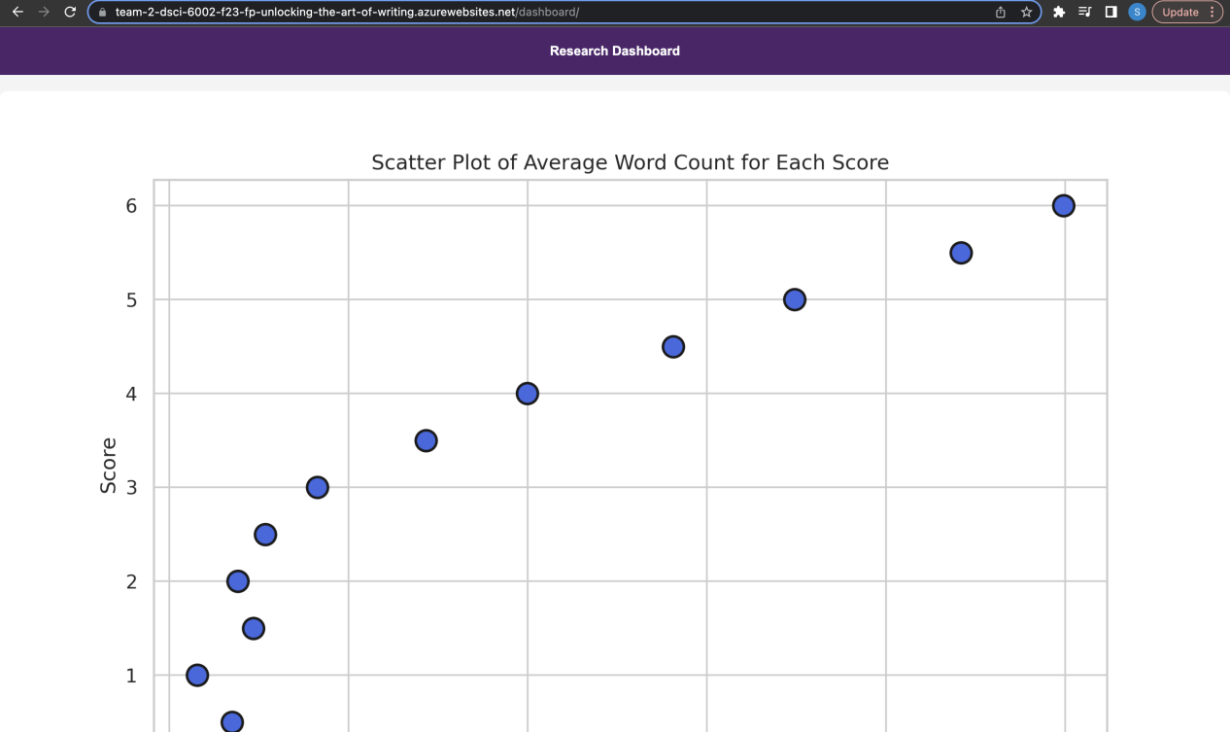

Fig 4.5.1 - Visualization Dashboard

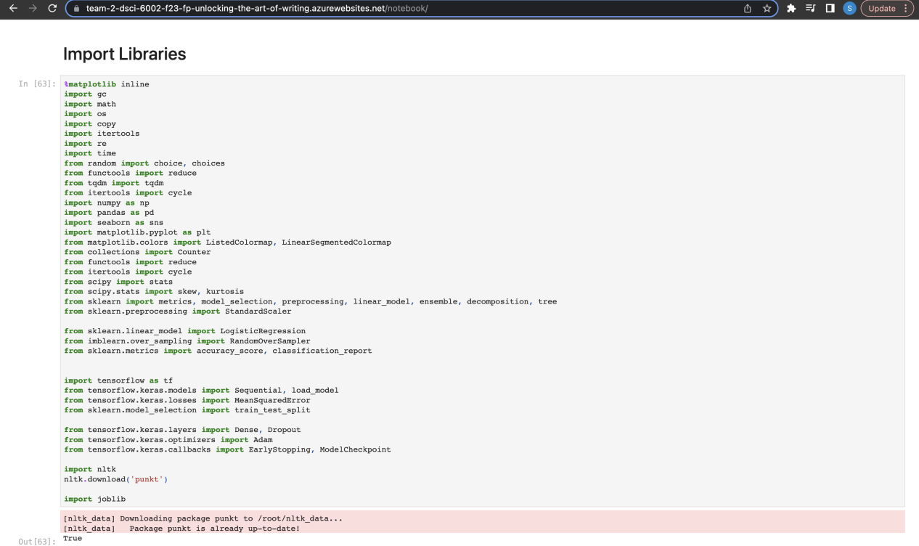

Fig 4.5.2 - Jupyter Notebook

### Screenshot 2023-12-06 at 1.50.59 AM

Fig 4.5.3 - Model Ingestion

### CONCLUSION

In examining the intricate relationship between the writing process and the resulting quality of written work, this study has revealed significant insights into the interplay of methodologies and the caliber of written content. The findings underscore the pivotal role of each stage in the writing process, from initial ideation through revision and editing, in shaping the overall quality of the composition.

This study's insights offer valuable implications for educators, writers, and practitioners in fostering effective writing practices. By recognizing the symbiotic relationship between writing methodologies and writing quality, stakeholders can devise tailored strategies to nurture and enhance writing abilities, ultimately fostering a culture of excellence in written communication across various domains. As the landscape of communication evolves, continued research in this domain remains pivotal for refining approaches and empowering individuals to excel in their written expression.

### FUTURE WORK

There are a number of interesting avenues for future research on the relationship between writing methods and writing quality. Cutting-edge analytical methods, such as the combination of machine learning and natural language processing, provide a way to explore the subtle differences in writing processes among different genres and populations. Through the tracking of writing skills over time, longitudinal studies provide light on effective instructional techniques and developmental trajectories. Furthermore, research into how cultural diversity and contextual elements affect writing styles and quality is still necessary in order to comprehend how sociocultural backgrounds influence written communication. Examining how technology is integrated, especially with AI-powered writing aides and collaborative platforms, creates opportunities to evaluate how technology affects writing techniques.

### REFERENCES

1. <https://www.kaggle.com/competitions/linking-writing-processes-to-writing-quality>
2. <https://www.tensorflow.org/api_docs/python/tf/keras/Sequential>
3. https://analyticsindiamag.com/a-tutorial-on-sequential-machine-learning/